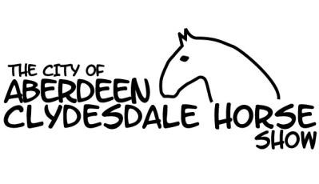

***Celebrating our 36th Anniversary Year***

***Duthie Park, Aberdeen***

***Saturday 25th August 2018***

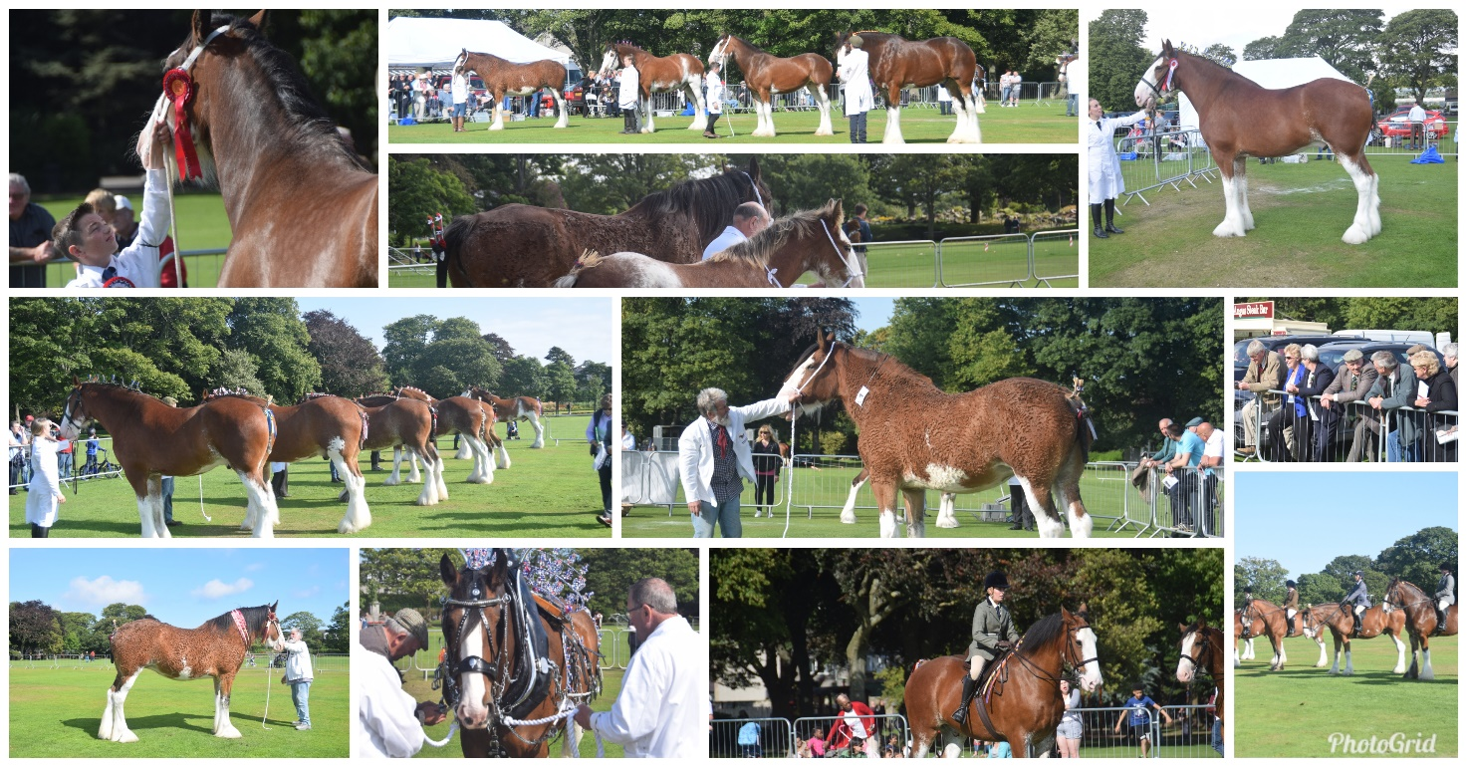

***“Be a part of, or enjoy, the largest gathering of Clydesdales in the N.E.”***

***In-hand, Ridden, Harness, Young Handler, Young Judge and Fancy Dress Classes.***

***Judging commences at 10.00 a.m.***

***Schedules & entry forms are available from Karen Campbell Call 01888 511499 Text 07554 960788***

***Email*** [***karen.campbell7868@googlemail.com***](mailto:karen.campbell7868@googlemail.com)